MYDRIVE FILE UPLOAD INSTRUCTIONS

IMPORTANT: The html file for the home page of your web site MUST be named index.html otherwise the URL you submit to the instructor will not render your web site properly.

Open your web browser and go to https://myDrive.nvcc.edu

Enter your myNOVA username and password (same credentials used for Canvas), then click the Sign in to MyDrive button.
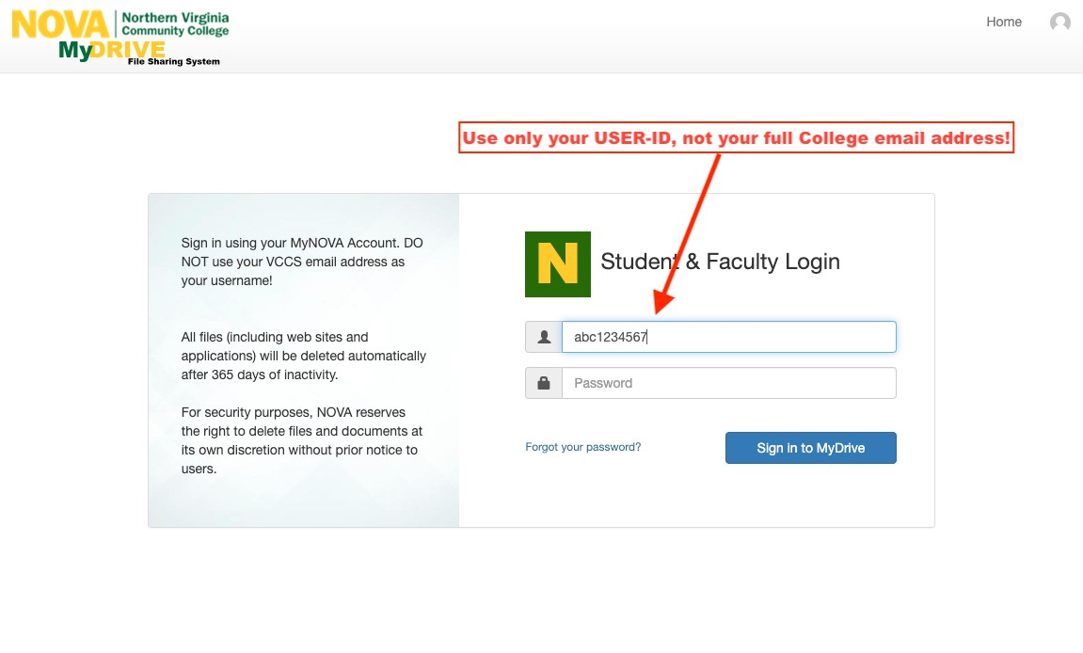
Same username you use to log into Canvas
Once you have successfully logged in, you will see the NOVA myDrive home page. Click on “My Student Web Folder”

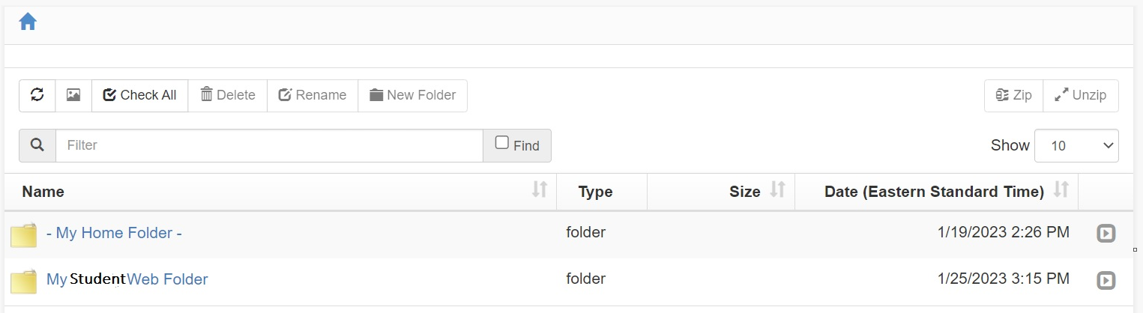

Click Add files. This will bring up File Explorer.

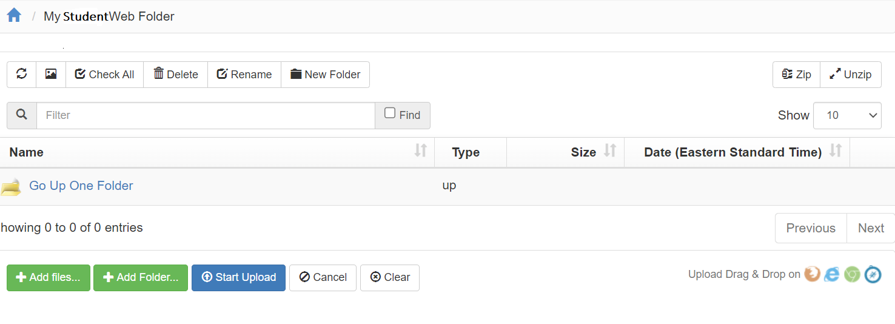

Navigate to the location where you have your files saved.
Select all files you want to upload to MyDrive. Click Open in File Explorer.

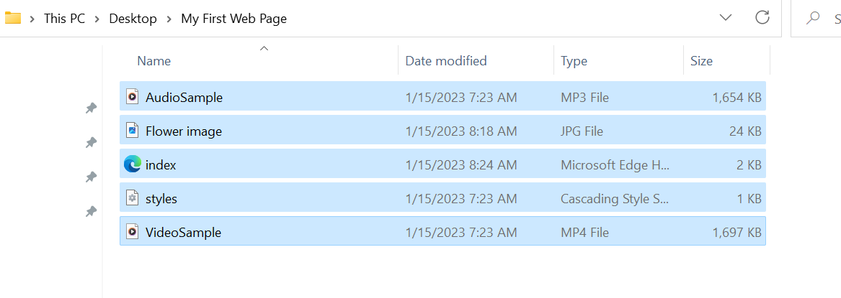

The files will now appear in the window BELOW the Add files button. To add these files to myDrive’s “My Student Web Folder”, click Start Upload. Note: the files listed are only examples, you will upload YOUR files.

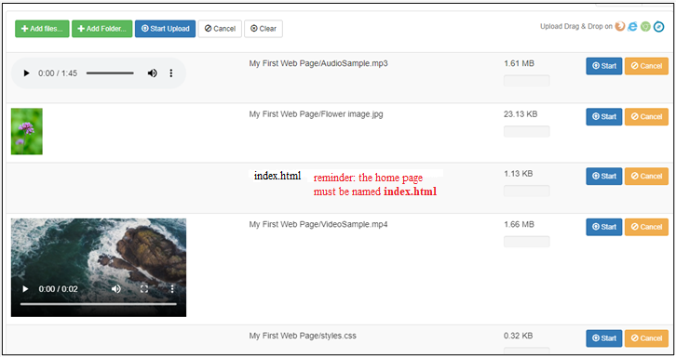

You will know the files are uploaded to myDrive when the files appear ABOVE the Add Files button.

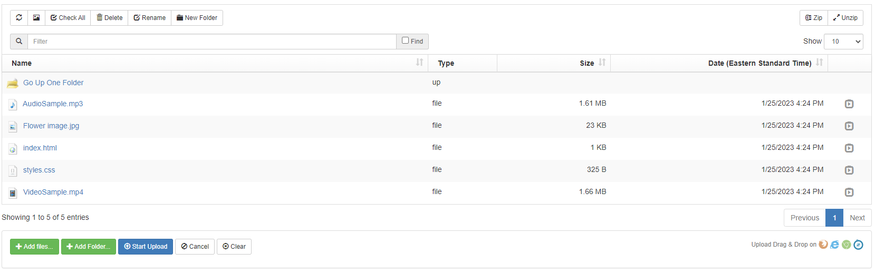

Once all files for your web site have been uploaded to the My Student Web Folder, you will submit the URL https://student.nvcc.edu/Username (Username will be replaced with your MyNOVA username) via the assignment submission link in Canvas.

- To test your URL open a new browser window and enter the URL. This will render your web page(s) so you can make sure it is working as expected. Keep in mind…whatever you see using your URL is what the instructor will also see.

